

**Semester One Examination, 2021**

**Question/Answer Booklet**

**MATHEMATICS**

**METHODS**

**ATAR Year 12**

**Section Two:**

**Calculator-assumed**

Student Name: ______________________________________________________

Please circle your teacher’s name

**Teacher: Miss Hosking Miss Rowden**

**Time allowed for this paper**

Reading time before commencing work: 10 minutes

Working time for paper: 100 minutes

**Materials required/recommended for this paper**

***To be provided by the supervisor***

Number of additional

answer booklets used

(if applicable):

This Question/Answer Booklet

Formula Sheet (retained from Section One)

***To be provided by the candidate***

Standard items: pens (blue/black preferred), pencils (including coloured), sharpener, correction fluid/tape, eraser, ruler, highlighters

Special items: drawing instruments, templates, notes on two unfolded sheets of A4 paper, and up to three calculators approved for use in this examination

**Important note to candidates**

No other items may be taken into the examination room. It is **your** responsibility to ensure that you do not have any unauthorised material. If you have any unauthorised material with you, hand it to the supervisor **before** reading any further.

**Structure of this paper**

|  |  |  |  |  |  |
| --- | --- | --- | --- | --- | --- |
| Section | Number of questions available | Number of questions to be answered | Suggested working time (minutes) | Marks available | Percentage of examination |
| Section One:  Calculator free | 8 | 8 | 50 | 52 | 35 |
| Section Two:  Calculator-assumed | 13 | 13 | 100 | 98 | 65 |
|  |  |  |  | **Total** | 100 |

**Instructions to candidates**

1. The rules for the conduct of the ATAR course examinations are detailed in the *Year 12 Information Handbook 2021*. Sitting this examination implies that you agree to abide by these rules.
2. Write your answers in this Question/Answer booklet.
3. You must be careful to confine your answers to the specific questions asked and to follow any instructions that are specific to a particular question.
4. Supplementary pages for the use planning/continuing your answer to a question have been provided at the end of the Question/Answer booklet. If you use these pages to continue an answer, indicate at the original answer where the answer is continued, i.e. give the page number.
5. Show all your working clearly. Your working should be in sufficient detail to allow your answers to be checked readily and for marks to be awarded for reasoning. Incorrect answers given without supporting reasoning cannot be allocated any marks. For any question or part question worth more than two marks, valid working or justification is required to receive full marks. If you repeat any question, ensure that you cancel the answer you do not wish to have marked.
6. It is recommended that you do not use pencil, except in diagrams.
7. The Formula sheet is not to be handed in with your Question/Answer booklet.

**Section Two: Calculator-assumed 65% (98 Marks)**

This section has thirteen (13) questions. Answer **all** questions. Write your answers in the spaces provided.

Supplementary pages for the use of planning/continuing your answer to a question have been provided at the end of this Question/Answer booklet. If you use these pages to continue an answer, indicate at the original answer where the answer is continued, i.e. give the page number.

Working time: 100 minutes.

Question 9 (7 marks)

A hot potato was removed from an oven and placed on a cooling rack. Its temperature $T$, in degrees Celsius, $t$ minutes after being removed from the oven was modelled by

$$T=16+188e^{kt}.$$

The temperature of the potato halved between $t=0$ and $t=6.8$.

(a) Determine the value of the constant $k$. (3 marks)

(b) The temperature of the potato eventually reached a a stable temperature. Determine the time taken for its temperature to first fall to within $4 °C$ of this stable temperature. (2 marks)

(c) Determine the time at which the potato was cooling at a rate of $4 °C$ per minute.

(2 marks)

Question 10 (8 marks)

Let $f\left(x\right)={3x}^{4}+ax^{2}+1$.

(a) Sketch the graph of $y=f(x)$ when $a=-24$. (4 marks)

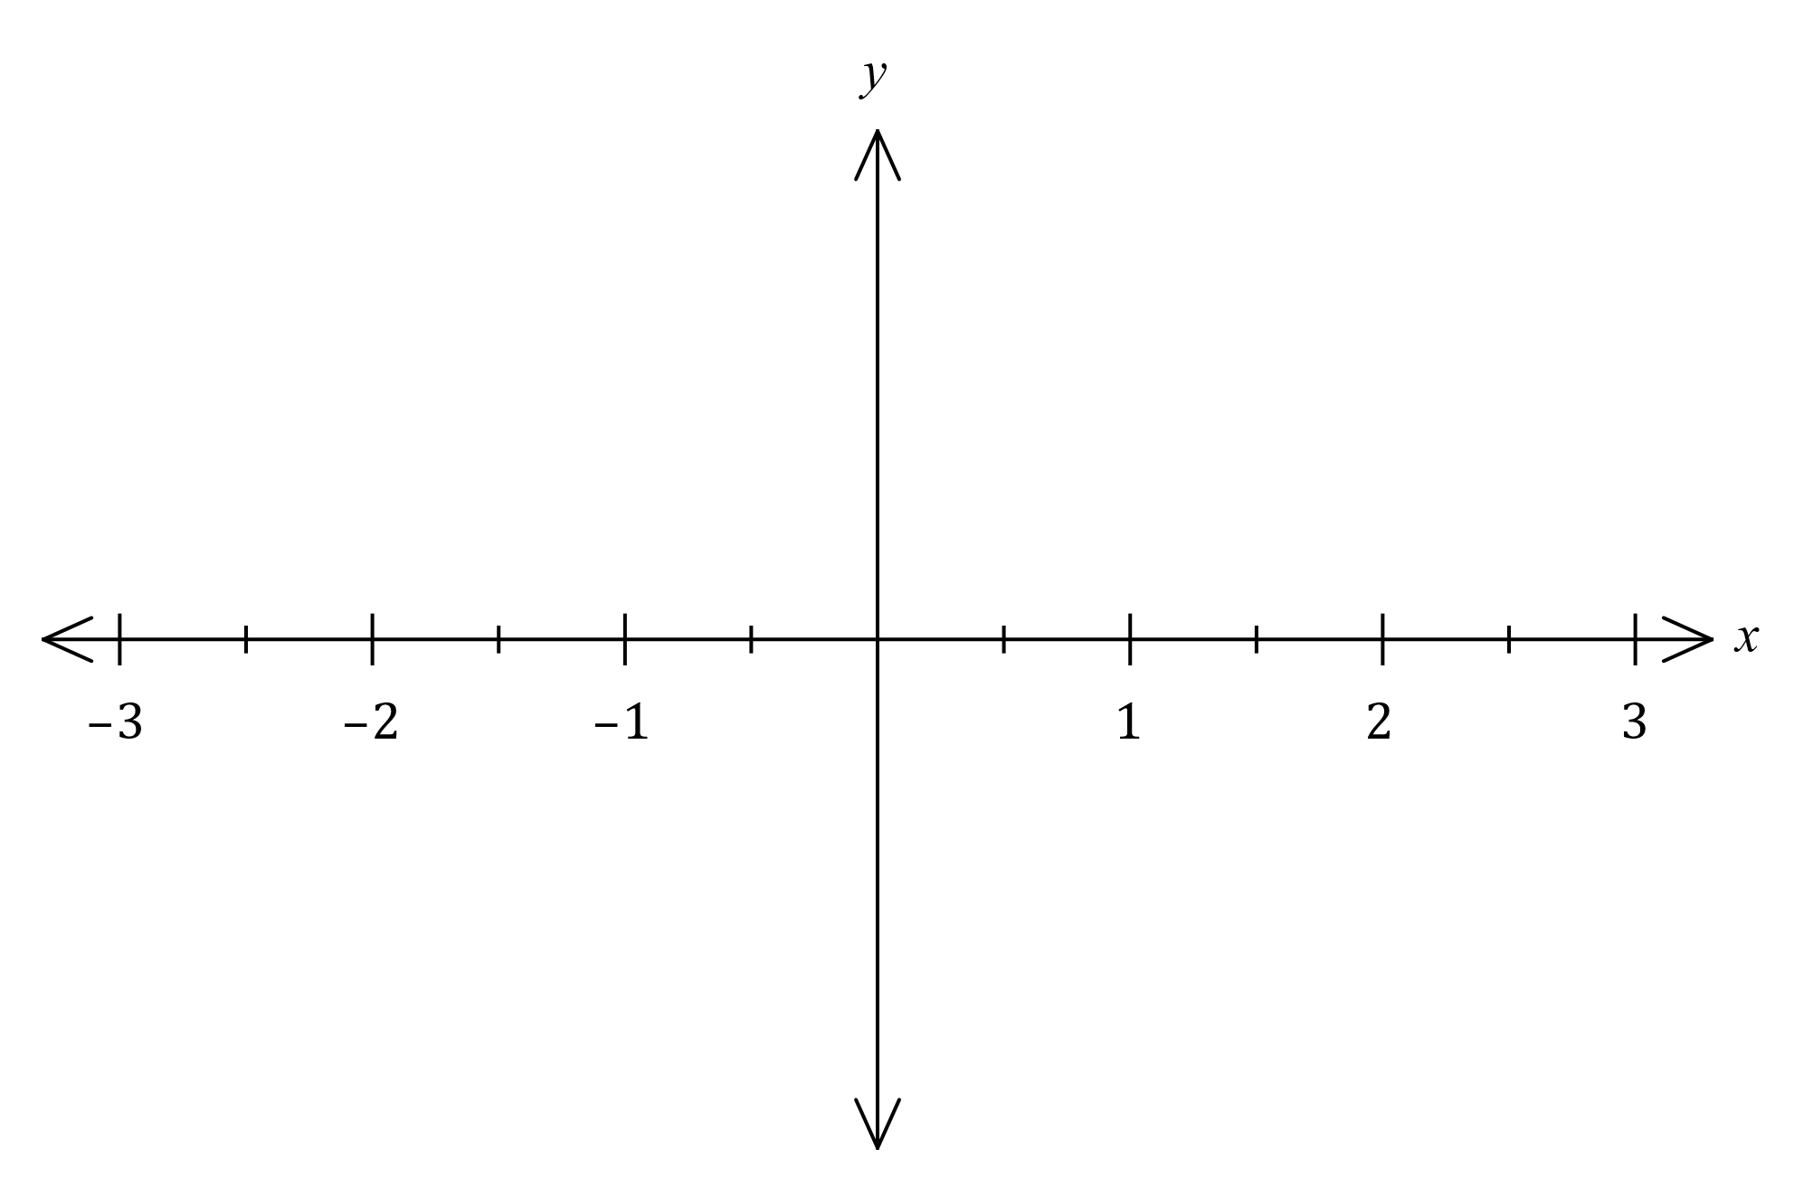

(b) Show that the graph of $y=f(x)$ will always have a maximum turning point at $x=0$  
if $a<0$. (4 marks)

Question 11 (8 marks)

The graph of function $g$, and a table of values for function $f$ and its derivatives are shown below.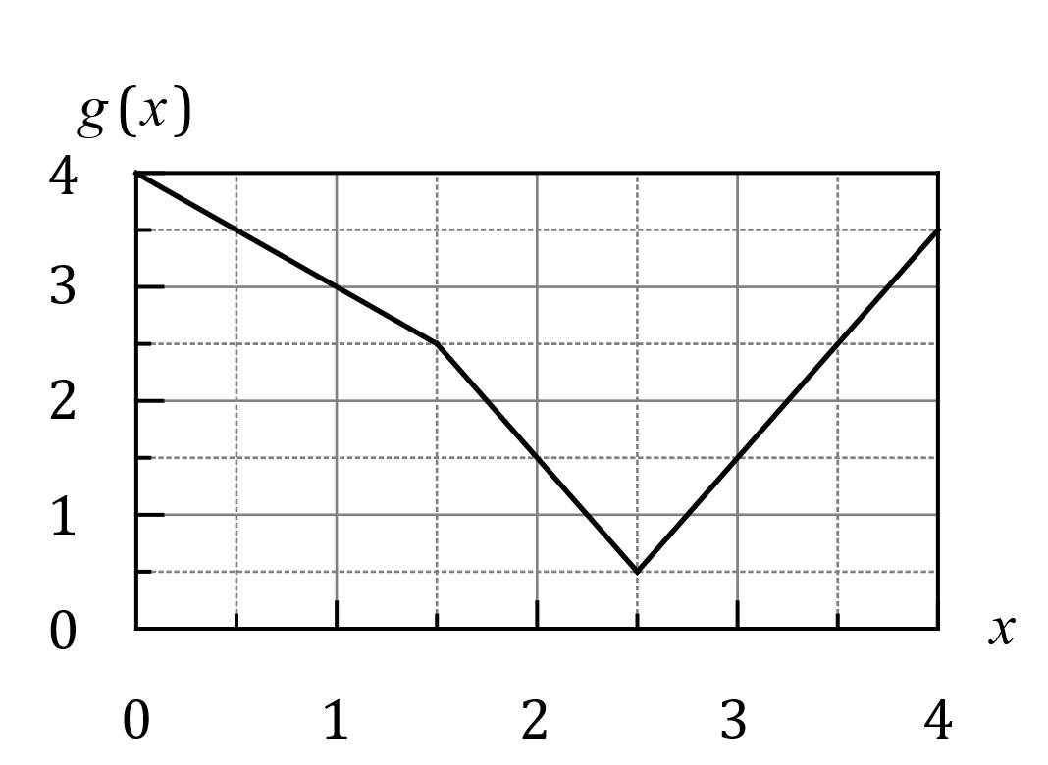

|  |  |  |  |
| --- | --- | --- | --- |
| $$x$$ | $$1$$ | $$2$$ | $$3$$ |
| $$f(x)$$ | $$3$$ | $$1$$ | $$2$$ |
| $$f'(x)$$ | $$1$$ | $$4$$ | $$2$$ |
| $$f''(x)$$ | $$2$$ | $$-1$$ | $$-2$$ |

(a) Evaluate $h'(k)$ when

(i) $h\left(x\right)=f\left(g\left(x\right)\right)$ and $k=1$. (3 marks)

(ii) $h\left(x\right)=g\left(x\right)÷f\left(x\right)$ and $k=2$. (3 marks)

(b) Evaluate $h''(3)$ when $h'\left(x\right)=f'\left(x\right)×g'\left(x\right)$. (2 marks)

Question 12 (10 marks)

(a) If and  then, in terms of  and , determine:

(i)  (1 marks)

(ii)  (2 marks)

(iii)  (3 marks)

Question 12 continued

(b) The loudness *L,* in decibels, of sound is given by the equation determine:



Where is the intensity of sound and is the intensity of the sound just audible to the human ear.

(i) Find the loudness if the sound is 140 times as intense as . (2 marks)

(ii) If the loudness was 28dB find in terms of intensity of sound. (2 marks)

Question 13 (8 marks)

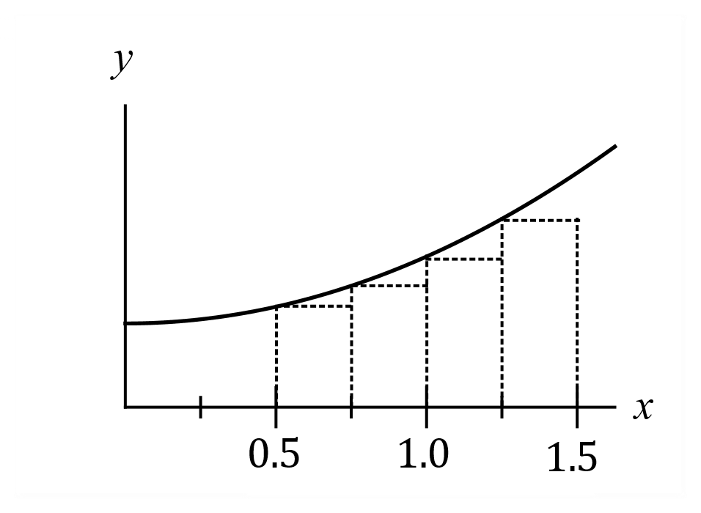The graph of $y=f\left(x\right)$ is shown at right with $4$ equal  
width inscribed rectangles. An estimate for the area  
under the curve between $x=0.5$ and $x=1.5$ is required.  
  
The function $f$ is defined as $f\left(x\right)=2x^{2}+7$ and let  
the area sum of the $4$ rectangles be $S_{4}$. $S_{n}$ 
  
, the area estimate using $n$ inscribed rectangles can  
be calculated using $$S_{n}=\sum_{i=1}^{i=n}{f\left(x_{i}\right)δx}$$

(a) State the values of $x_{1}, x_{2}, x_{3}, x_{4}$ and $δx$ that should be used to determine $S_{4}$. (1 mark)

(b) Calculate the value of $S_{4}$. (3 marks)

(c) Explain, with reasons, how the value of $δx$ and the area estimate $S_{n}$ will change as the number of inscribed rectangles increase. (2 marks)

(d) Determine the limiting value of $S_{n}$ as $n→∞$. (2 marks)

Question 14 (6 marks)

The area $A$ of a regular polygon with $n$ sides of length $x$ is given by

$$A=\frac{n x^{2}\cos\left(\frac{π}{n}\right)}{4\sin\left(\frac{π}{n}\right)}$$

(a) Determine the exact area of a regular hexagon with side length 3 cm. (1 mark)

(b) Simplify the above formula when $n=12$ to obtain a function for the area of a regular dodecagon. (2 marks)

(c) Use the increments formula to estimate the change in area of a regular dodecagon when its side length increases from $10$ cm to $10.3$ cm. (3 marks)

Question 15 (8 marks)

Hick's law, shown below, models the average time, $T$ seconds, for a person to make a

selection when presented with $n$ equally probable choices.

$T=a+b\log_{2}{(n+1)}$, where $a$ and $b$ are positive constants.

(a) Draw the graph of $T$ vs $n$ on the axes below when $a=4$ and $b=8$. (3 marks)

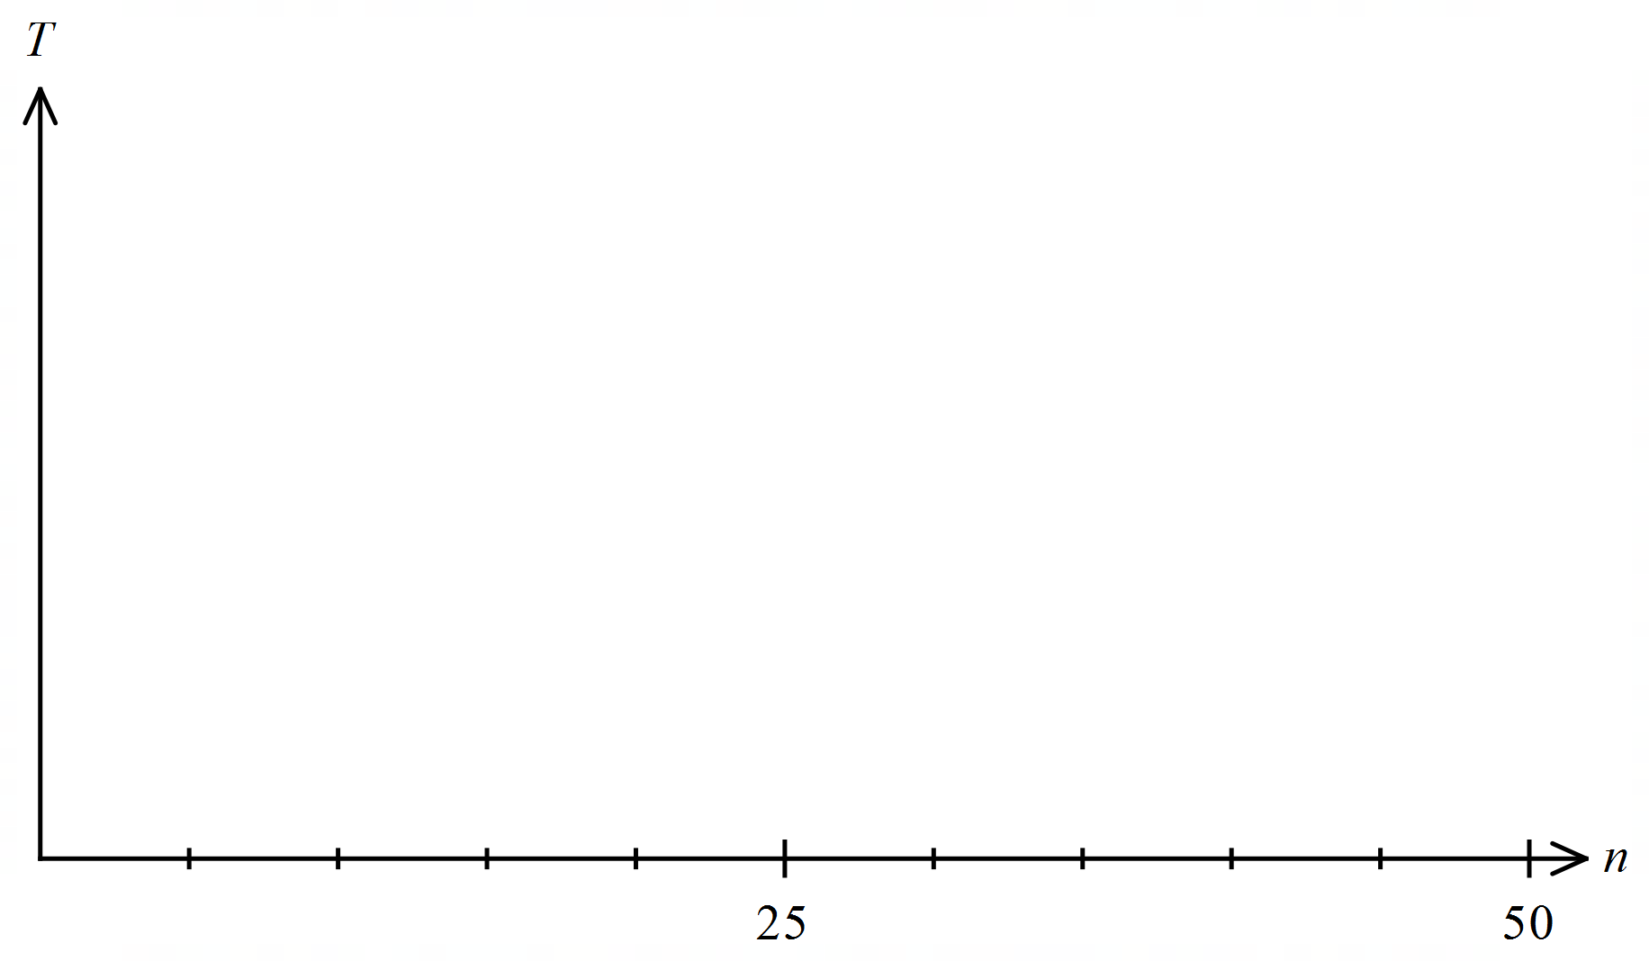

(b) When a pizzeria had 10 choices of pizza, the average time for patrons to make a choice was 40 seconds. After doubling the number of choices, the average time to make their choice increased by 25%.

Modelling the relationship with Hick's law, predict the average time to make a choice if patrons were offered a choice of 35 pizzas. (5 marks)

Question 16 (8 marks)

The volume, $V$ litres, of fuel in a tank is reduced between $t=0$ and $t=48$ minutes so that

$$\frac{dV}{dt}=-175π\sin\left(\begin{matrix}πt \\ \overline{48}\end{matrix}\right)$$

(a) Determine, to the nearest litre, the amount of fuel emptied from the tank

(i) in the first minute. (3 marks)

(ii) in the last $7$ minutes. (1 mark)

The tank initially held $18 600$ litres of fuel.

(b) Determine the volume of fuel in the tank $5$ minutes after the volume in the tank reached $12 000$ litres. (4 marks)

Question 17 (7 marks)

Regions $A, B, C$ and $D$ bounded by the curve $y=f(x)$ and the $x$-axis are shown on this graph:

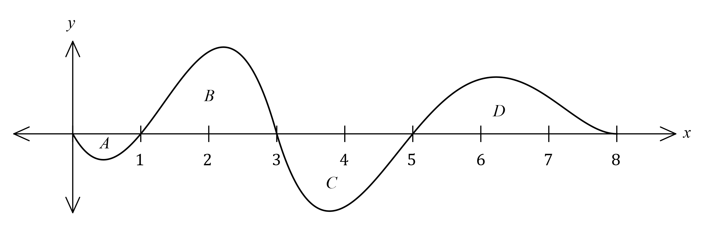

The areas of $A, B, C$ and $D$ are $5, 31, 27$ and $23$ square units respectively.

(a) Determine the value of

(i) $\int_{0}^{3}{\underset{ }{\overset{ }{f(x)}}}dx$. (1 mark)

(ii) $\int_{3}^{8}{\underset{ }{\overset{ }{4f(x)}}}dx$. (2 marks)

(iii) $\int_{1}^{8}{\underset{ }{(5-\overset{ }{f(x))}}}dx$. (2 marks)

(b) Explain why $\int_{1}^{5}{\underset{ }{\overset{ }{f'(x)}}}dx=0$. (2 marks)

Question 18 (7 marks)

The table below shows the sign of the polynomial $f(x)$ and some of its derivatives at various values of $x$. There are no other zeroes of $f\left(x\right), f'(x)$ or $f''(x)$ apart from those shown in the table.

|  |  |  |  |  |  |  |  |
| --- | --- | --- | --- | --- | --- | --- | --- |
| $$x$$ | $$-2$$ | $$-1$$ | $$0$$ | $$1$$ | $$2$$ | $$3$$ | $$4$$ |
| $$f(x)$$ | $$-$$ | $$0$$ | $$+$$ | $$+$$ | $$+$$ | $$0$$ | $$-$$ |
| $$f'(x)$$ | $$+$$ | $$+$$ | $$0$$ | $$-$$ | $$-$$ | $$0$$ | $$-$$ |
| $$f''(x)$$ | $$-$$ | $$-$$ | $$-$$ | $$0$$ | $$+$$ | $$0$$ | $$-$$ |

(a) For what value(s) of $x$ is the graph of the function concave down? (1 mark)

(b) At what location does the graph of $f$ have a turning point? Explain your answer.

(2 marks)

(c) Sketch a possible graph of $y=f(x)$ on the axes below. (4 marks)

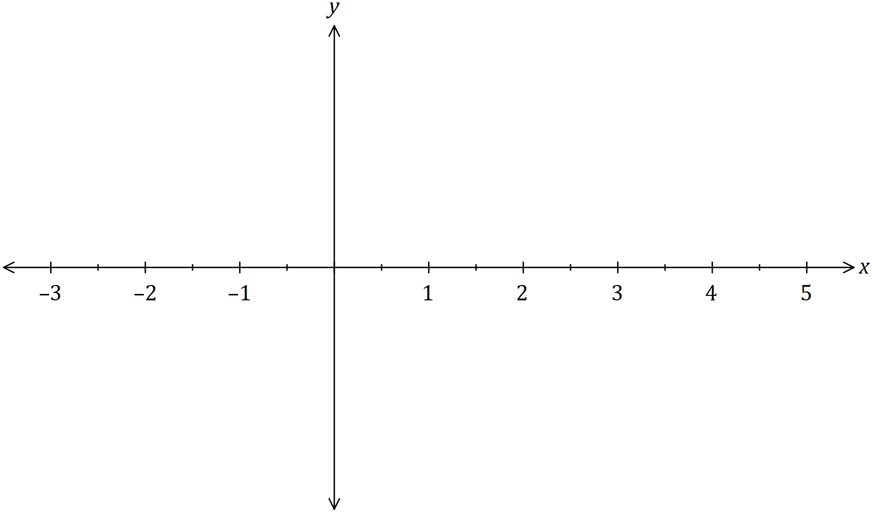

Question 19 (8 marks)

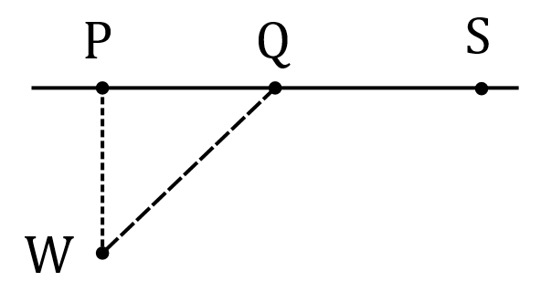An offshore wind turbine $W$ lies $12$ km away from the nearest  
point $P$ on a straight coast. It must be connected to a power  
storage facility $S$ that lies on the coast $24$ km away from $P$.

Engineers will lay the cable in two straight sections,  
from $W$ to $Q$, where $Q$ is a point on the coast $x$ km from $P$,  
and then from $Q$ to $S$.

The cost of installing cable along the coastline is $\$1000$ per km and offshore is $\$2600$ per km.

(a) Determine, to the nearest hundred dollars, the cost of installing the cable when $Q$ lies midway from $S$ to $P$. (2 marks)

(b) Show that $C$, the cost in hundreds of dollars, to run the cable from $W$ to $Q$ to $S$, is given by $C=26\sqrt{x^{2}+144}-10x+240$. (2 marks)

(c) Use calculus techniques to determine, with justification, the minimum cost of laying the cable from $W$ to $S$. (4 marks)

Question 20 (8 marks)

Small body $A$ moves in a straight line with acceleration cm/s2 at time $t$ s given by

$$a=pt+q$$

Initially, $A$ has a displacement of $4$ cm relative to a fixed point $O$ and is moving with a velocity of $9$ cm/s. Two seconds later, $A$ has a displacement of $8.8$ cm and a velocity of $-3.6$ cm/s.

(a) Determine the value of the constant $p$ and the value of the constant $q$. (6 marks)

(b) Determine the minimum velocity of $A$. (2 marks)

Question 21 (5 marks)

(a) Determine the value of the constant $a$ and the value of the constant $b$ that make each of the following statements true, given that $f(x)$ is a polynomial:

(i) $\int_{a}^{1}{\underset{ }{\overset{ }{f(x)}}}dx+\int_{1}^{b}{\underset{ }{\overset{ }{f(x)}}}dx=\int_{-3}^{2}{\underset{ }{\overset{ }{f(x)}}}dx$. (1 mark)

(ii) $\int_{0}^{2}{\underset{ }{\overset{ }{f(x)}}}dx-\int_{1}^{2}{\underset{ }{\overset{ }{f\left(x\right)}}}dx+\int_{-1}^{0}{\underset{ }{\overset{ }{f(x)}}}dx=\int_{a}^{b}{\underset{ }{\overset{ }{f(x)}}}dx$. (2 marks)

(b) Determine $\begin{matrix}d \\ \overline{dx}\end{matrix}\left(\int_{g\left(x\right)}^{3}{\underset{ }{\overset{ }{f\left(t\right)}}}dt\right)$. (2 marks)

**End of questions**

Supplementary page

Question number: _____________________

Supplementary page

Question number: _____________________

Supplementary page

Question number: _____________________

Supplementary page

Question number: _____________________